WIRESHARK NEWORK TRAFFIC ANALYSIS LAB

1. Project Overview
This project establishes a virtualized Security Operations Center (SOC) packet analysis environment to simulate, capture, and investigate malicious network traffic signatures. Using Kali Linux as an adversary node and Ubuntu Server as the target/sensor node, multiple attack vectors—including Denial of Service (DoS) floods and reconnaissance sweeps—were executed and triaged in Wireshark.
The primary objective is to differentiate malicious automated activity from benign baseline traffic by analyzing packet header structures, TCP flags, and protocol behavior mapped to the **MITRE ATT&CK framework**.

2. Lab Architecture & Environment Topology
| Role | Operating System | Network Mode | Primary Role / Function |
| **Attacker Machine** | Kali Linux | Host-Only / NAT Network | Adversary node generating automated scans and floods |
| **Target / Sensor** | Ubuntu Server / Desktop | Host-Only / NAT Network | Monitored host running packet capture tools (`wireshark`, `tshark`, `tcpdump`) |

* **Network Subnet:** `192.168.56.0/24` (Isolated private segment)
* **Target IP:** `192.168.56.101`

3. Attack Execution & MITRE ATT&CK Mapping
The following attack vectors were executed from the Kali Linux adversary machine against the monitored Ubuntu target:

A. ICMP Flood / Rapid Ping (MITRE ATT&CK: T1498 - Denial of Service)
- Purpose: Exhaust target network socket buffers and overwhelm processing bandwidth via high-frequency ICMP Echo Requests.
- Execution Command: sudo hping3 --icmp -i u1000 -c 100 192.168.56.101

B. TCP SYN Stealth Scan (MITRE ATT&CK: T1046 - Network Service Discovery)
- Purpose: Identify open services across target ports by sending half-open SYN packets without completing the 3-way handshake.
- Execution Command:
Bash
sudo nmap -sS -p 21,22,80,443,8080 192.168.56.101
C. FIN Stealth Scan (MITRE ATT&CK: T1046 - Network Service Discovery)
- Purpose: Circumvent stateless firewalls and packet filters by transmitting unsolicited FIN packets to closed vs. open ports.
- Execution Command:
Bash
sudo nmap -sF -p 21,22,80,443 192.168.56.101
D. TCP SYN Burst (MITRE ATT&CK: T1498.001 - SYN Flood)
- Purpose: Simulate half-open resource exhaustion against port 80 to disrupt legitimate web services.
- Execution Command:
Bash
sudo hping3 -S -p 80 -c 100 --fast 192.168.56.101
E. Benign Baseline Generation
- Purpose: Inject standard HTTP/DNS traffic to contrast against malicious streams.
- Execution Command:
Bash
curl -I [http://192.168.56.101](http://192.168.56.101)
4. Wireshark Triage & Filter Reference
Triage Objective | Wireshark Display Filter | Packet Signature & Forensic Indicators
ICMP Flood Detection | icmp.type == 8 | Identifies bursts of high-rate ICMP Echo Requests arriving within milliseconds.
SYN Scan / Flood Triaging | tcp.flags.syn == 1 && tcp.flags.ack == 0 | Isolates half-open [SYN] connection attempts lacking corresponding [ACK] confirmations.
Closed Port Rejections | tcp.flags.reset == 1 | Displays [RST, ACK] packets generated by the target OS rejecting connections to closed ports scanned by Nmap.
FIN Scan Anomalies | tcp.flags.fin == 1 && tcp.flags.ack == 0 | Detects abnormal teardown requests sent without prior established TCP sessions.
Protocol Flow Verification | `arp
5. Visual Artifacts & Findings
1. Packet Burst Rate Spike (I/O Graph)
- Path: Statistics > I/O Graphs
- Finding: Demonstrates a distinct packet-per-second surge during the execution of hping3 and nmap relative to ambient network baselines.
(Insert screenshot: ./artifacts/io_graph_spike.png)
2. TCP SYN Packet Header Analysis
- Path: Display Filter tcp.flags.syn == 1 && tcp.flags.ack == 0
- Finding: Details the TCP header showing Flags: 0x002 (SYN) explicitly enabled with sequence numbers initialized for port discovery.
(Insert screenshot: ./artifacts/tcp_syn_details.png)
3. Closed Port Teardown (RST/ACK)
- Path: Display Filter tcp.flags.reset == 1
- Finding: Shows the target responding with Flags: 0x014 (RST, ACK) across non-listening ports (e.g., 21, 443), demonstrating OS-level scan response signatures.
(Insert screenshot: ./artifacts/tcp_rst_rejection.png)
4. TCP Conversations Breakdown
- Path: Statistics > Conversations > TCP
- Finding: Aggregates all communication streams, proving that a single adversary IP initiated numerous short-lived connections across distinct destination ports.
(Insert screenshot: ./artifacts/tcp_conversations.png)
6. Key Takeaways & Defense Recommendations
- Signature vs. Anomaly Detection: Automated port scans and packet floods leave distinct TCP flag combinations and abnormal request rates that can be systematically filtered using Layer 3/4 inspection.
- IDS/IPS Rule Creation: The captured patterns provide the baseline for writing custom Snort/Suricata rules (e.g., alerting on $>20$ SYN packets without ACK within 5 seconds from a single IP).
- Firewall Hardening: Implementing rate-limiting on ICMP traffic and dropping unsolicited FIN packets at the perimeter prevents internal network topology mapping.
7. Repository Structure
Plaintext
├── README.md
├── captures/
│ └── network_traffic_lab.pcapng
└── artifacts/
├── io_graph_spike.png
├── tcp_syn_details.png
├── tcp_rst_rejection.png
└── tcp_conversations.png
Analysis Result:
ICMP flood: icmp.type == 8
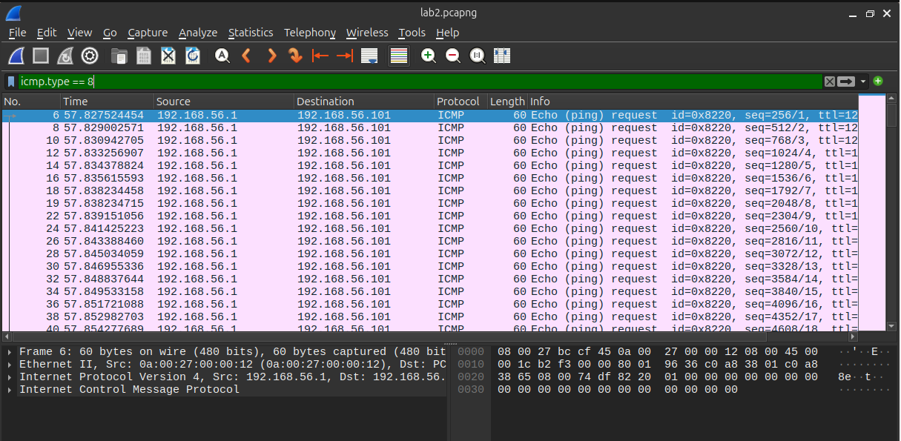
SYN Packets: tcp.flags.syn == 1 && tcp.flags.ack == 0
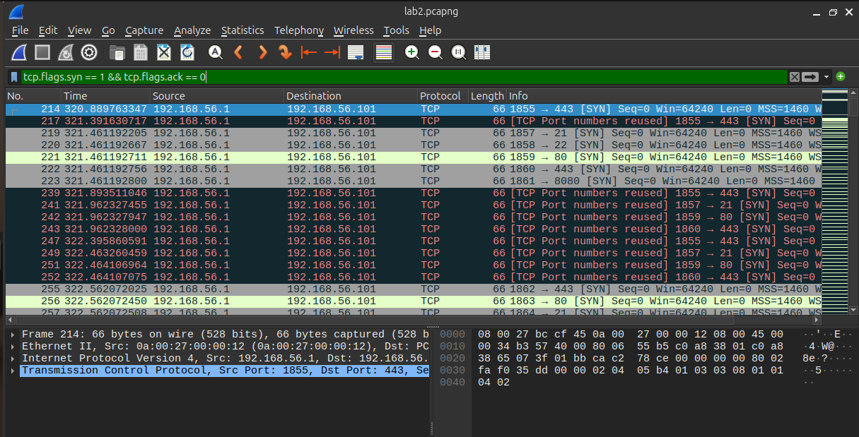
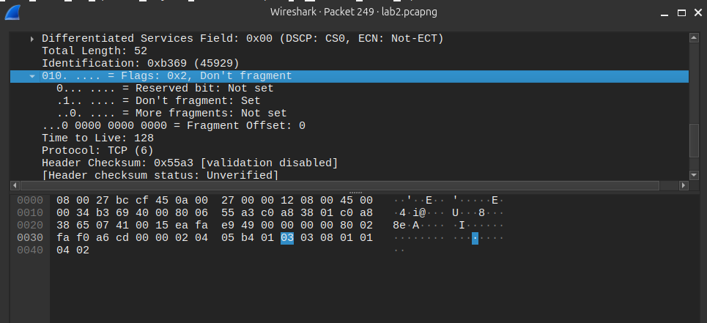

Port scan resets: tcp.flags.reset == 1
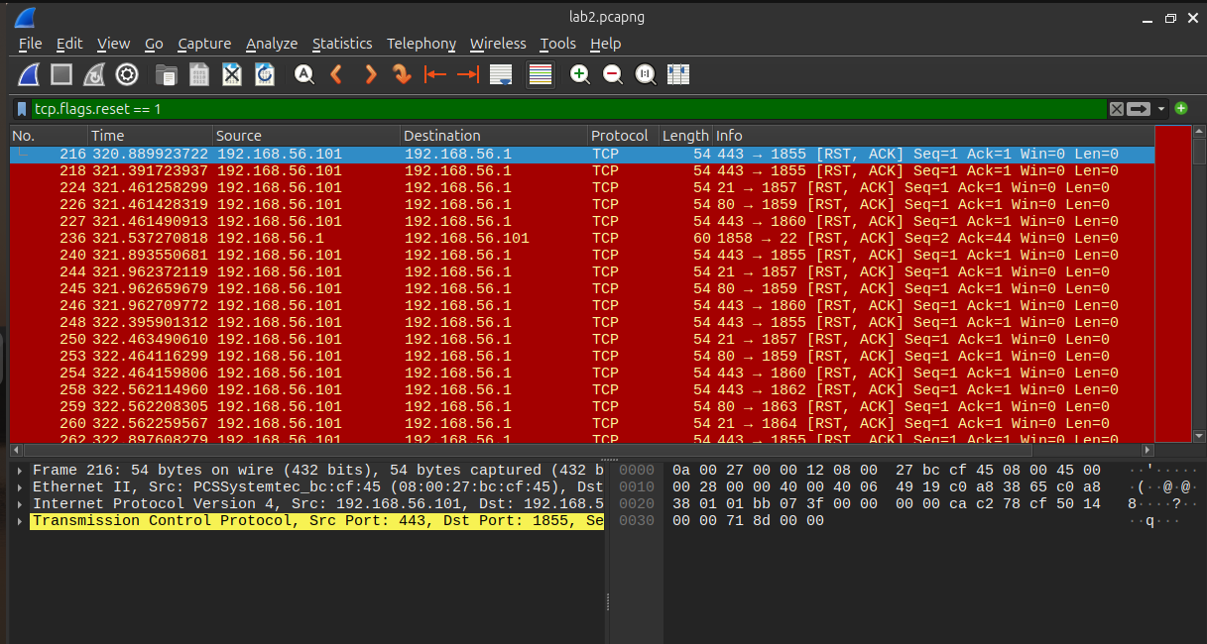
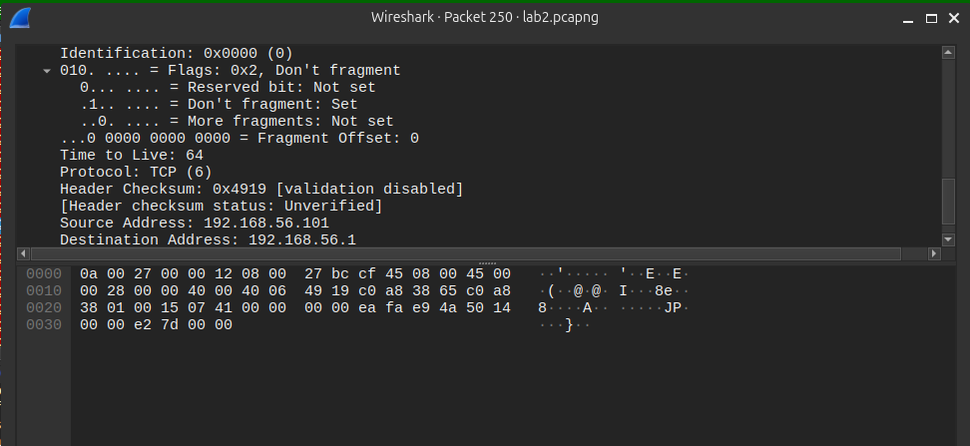

FIN scan: tcp.flags.fin == 1
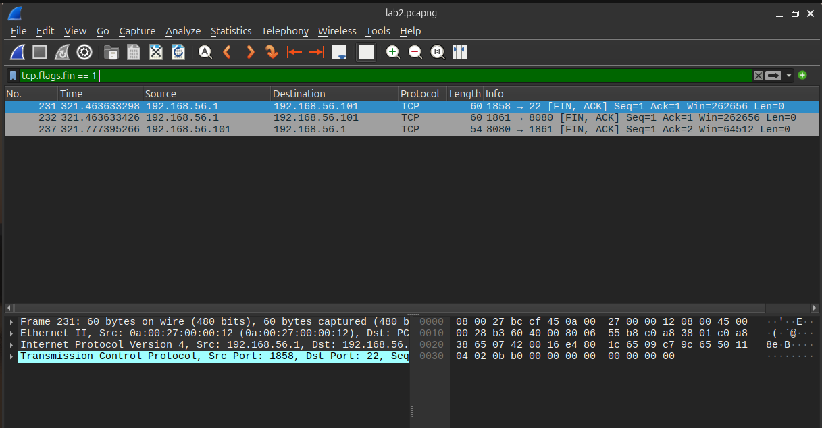

I/O graph
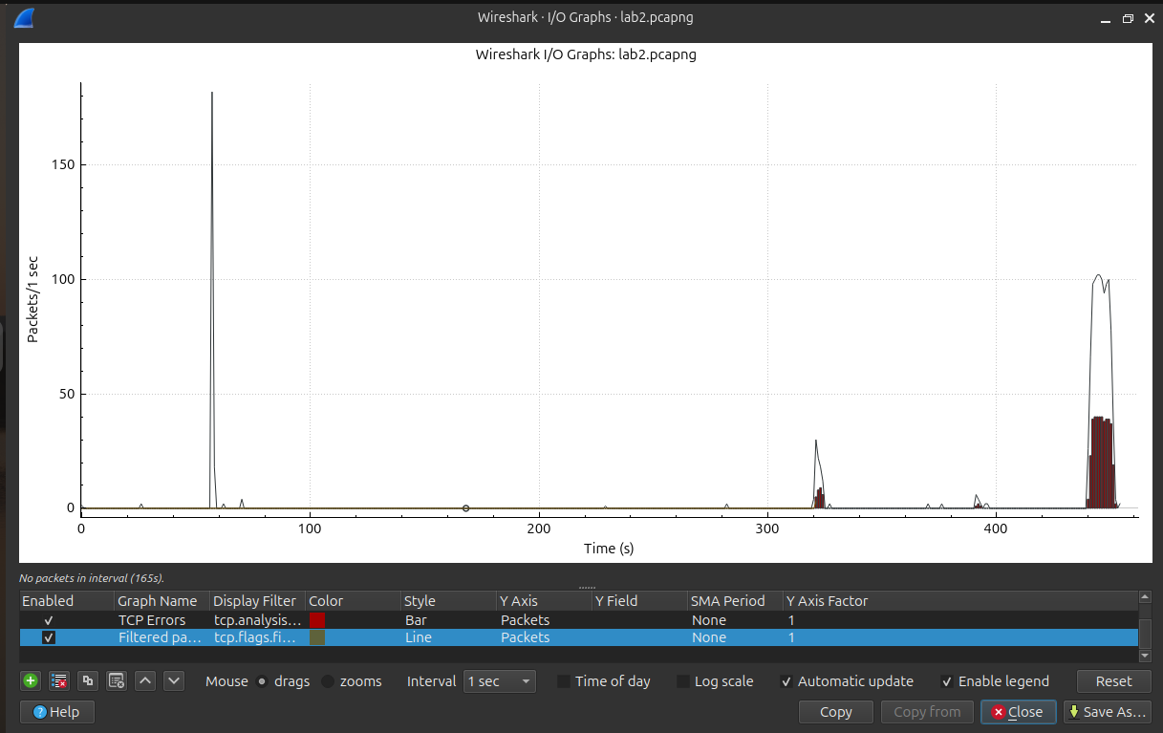

Conversation summary